**AP Bio 22-23 Notes**

# **Unit 7: Evolution**

## 7.1-7.3 7.12 Watch Its

* + [Natural Selection](https://youtu.be/R6La6_kIr9g)
    - **Darwin**
      * Fist scientist who explained evolution effectively
    - **Evolution**
      * Any changes to the **gene pool**
        + Combination all alleles of a population
      * Gene pools remain at equilibrium (freq) unless 5 constraints are violated
        + **Hardy-weinberg equllibrium (**[Hardy-Weinberg Equation](https://www.youtube.com/watch?v=oEBNom3K9cQ&ab_channel=BozemanScience)**)**

Equation used to determine the frequency of genes in a population

P = frequency of dominant allele

q = frequency of recessive allele

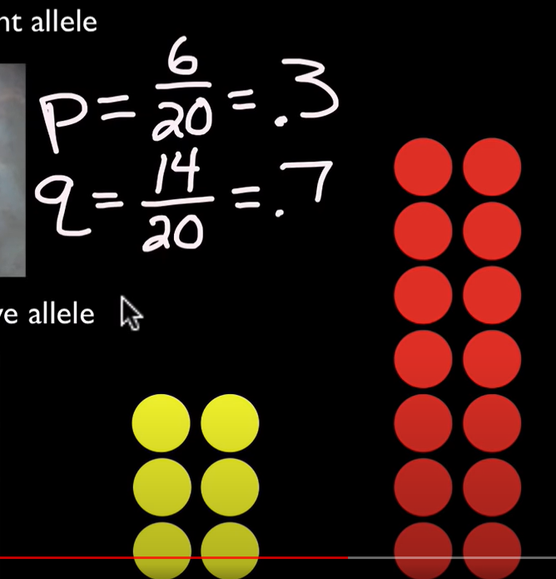

P + q = 1

$p^{2}+2pq+q^{2}=1$

Frequency of different genotypes

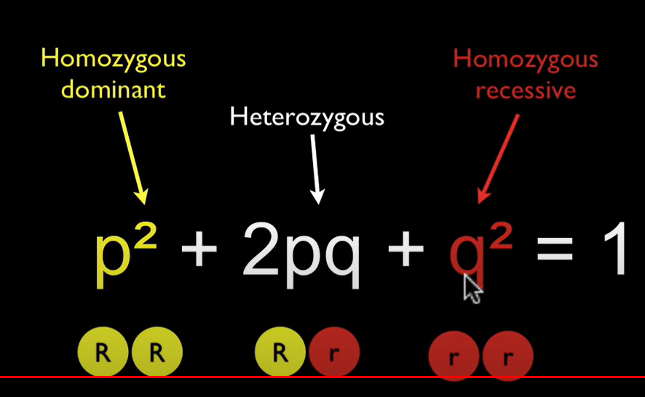

Homozygous dominant

Both copies of dominant allele

Heterozygous

1 of recessive & 1 of dominant allele

Homozygous recessive

Both copies of recessive allele

Ex problem

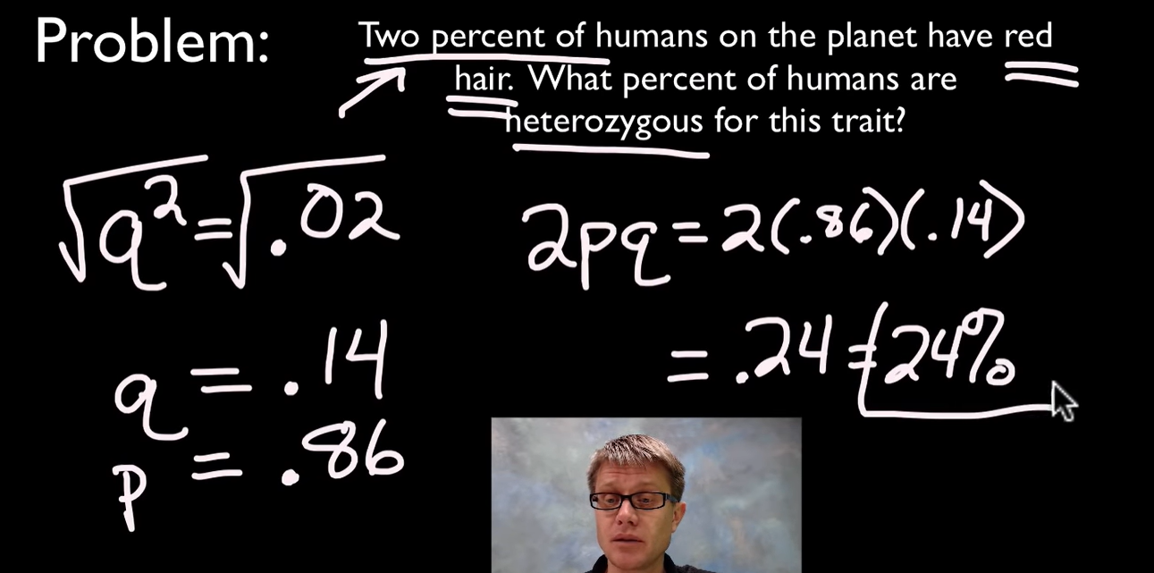

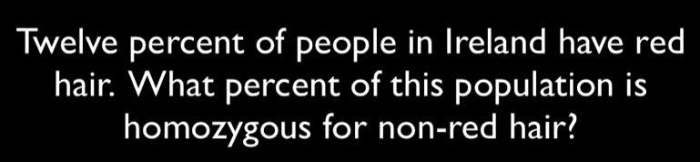

Red = recessive

Solving for p^2

$q^{2}=.12$

$q=.35$

$p = .65$

$p^{2} = .4225$

42.25% of people!

**Phenotype**

Physical characteristics of an organism

Caused by **genes**

Section of DNA that codes for phenotypes

Different types of genes are called **alleles**

Can be recessive or dominant

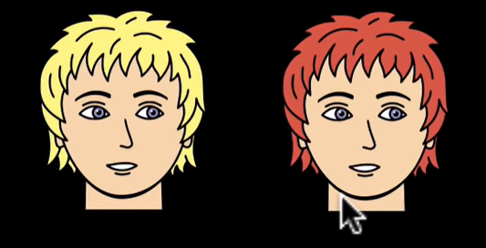

**Genotype**

The genes that an individual possesses

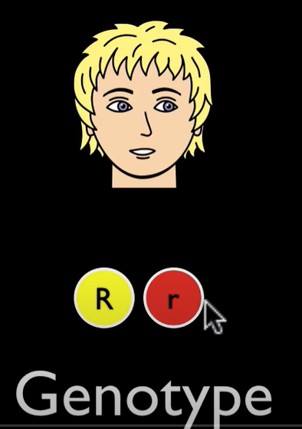

Carries genes that we can’t see by looking at

Only know genotype of some1 who has two recessive allles

* + - * + 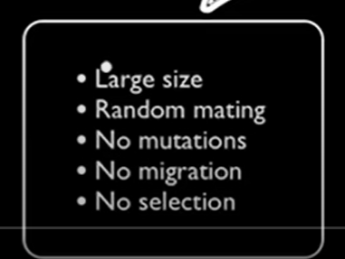
    - **Selection**
      * When you live or die
        + Differential repredictive success
    - **Natural selection**
      * Where your **environment** changes
        + You have **fitness** to survice

Pass on genes

Enough fitness leads to adaptations

* + - * + You don’t have fitness to change and die
      * Differential reproductive success
        + Each made are a lil diff & allowsus to survive
      * Leads to adaptations
      * 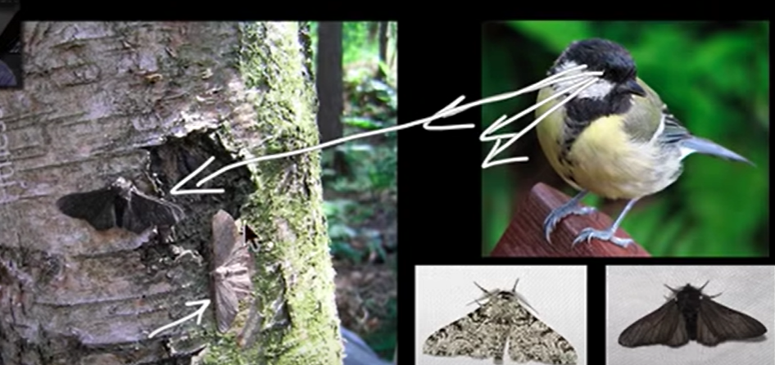
        + Predator selects the dark moth & genes die with it
        + Light moth therefore has higher fitness
    - **Mutation**
      * Change in DNA
      * Reproduction creates variety of DNA
    - **Adaptation**
      * Process
  + 7.1 Collegeboard
    - What is natural selection
      * Major mechanism of **evolution**
        + Change int he genetic makeup of a population overtime
      * Process by which organisms having adaptations suited for their environment have a greater chance of survival and reproduction, thereby passing adaptions to subsequent generations
      * Conditions for evolution by nat selection
      * **Competition**
        + Hwen organisms are struggling with other organisms

Space food nutrients

* + - * + Differences in phenotypes determine how competitive an organism is
      * **Variation**
        + Genetic differences among organisms of a population
        + Mutations and sexual reproduction increase variation within populations
      * **Adaptations**
        + Traits that provide an advantage to a particular enviornment
      * **Fitness**
        + Ability of an organism to survive and produce fertile offspring
      * **Reproductive success** 
        + Production of offspring
        + RS over several generations is a component of evolutionary fitness
      * **Heritability**
        + The ability to pass on adaptations to successive generations
        + Contribute to evolutionary fitness
      * Ecosystem stability
        + Determines the rate and direction of evolution

Biotic

abiotic

* + - What factors influence
    - How does nat selection influence populations

## 7.1-7.3 7.12 Read Its ([Figure Slides](https://docs.google.com/presentation/d/1Bd4b5Fq21zeWqtnMOuRg7BqFUna5V2MFstgzgcwJUq8/edit#slide=id.g16335e95d3_2_178))

### Ch 22.1 (7.1)

* + - *Descent with Modification: A Darwinian View of Life*
      * Darwin sought to explain the diversity of life
      * Created by **evolution**
        + Define evolution broadly and then give a narrower definition, as discussed in the overview.
        + Broad:

Descent with modification

Where species accumulate differences from their ancestors as they adapt to different environment over time

* + - * + Narrow:

Change in the genetic composition of a population from generation from generation

* + - * **Enviornment**
        + Other organisms & the physical aspect of an organisms surroundings
      * **Evolution**
        + As a pattern

Evolutionary change is revealed by data from scientific disciplines

Bio

Chem

Phys

Geology

Facts

Observations ab the natural world that show that change has occurred over time

Evolution can be viewed as a pattern and as a process. The pattern is a fact; how is the pattern revealed?

Through observations and facts

* + - * + As a process

Mechanisms that cause patterns of change

Natural causes of the natural phenomena we observe

What is the process of evolution?

Mechanisms that cause the patterns of change

* + - * **Scala Naturae**
        + Linear hierarchy species classification method
        + By Aristotle
        + Today, we use Linnaeus binomial format

Homo Spaien

### Ch 22.2 (7.1 & 7.3)

* + - *Descent with modification by natural selection explains the adaptations of organisms and the unity and diversity of life*
      * Darwin left England to observe plants and animals along the the South American coast
      * Charles Darwin proposed that the mechanism of evolution is natural selection and that it explains how adaptations arise. What are adaptations?
      * Observed fossils through natural changes
        + earfquakes
      * Darwin observed examples of **adaptations**
        + Inherited cahracteristscs of organisms

enhance theri survival and reproduction in specific environments

* + - * + Explained how adaptations arose throught he process of **Natural selection**

Key features

Indiivudals do not evolve but populations over time

Nat selec can amplify or dimisn only heritable traits taht differ

If only one trait exists, nat selec cannot occur

Enviornmental factors vary from place to place & over time. Nat selec always takes place but the favored traits depends on the environment in which a species mates

Explain the process of natural selection.

Individuals that have certain inherited traits tend to survive and reproduce at high rates than do other individuals

Because of those traits.

* + - * + Explain how adaptations, like the beaks of these finches, arise through natural selection.

The finches who were born with alleles better suited for their environment were more likely to survive and reproduce, and hence pass on their genes, than finches who were born with different alleles. A finch with the genes for a larger beak were more likely to survive in an environment with cacti than other birds with different genes.

* + - * Darwin viewed the history of life as a tree
        + Branchings from a common trunk

Twigs today

* + - * + 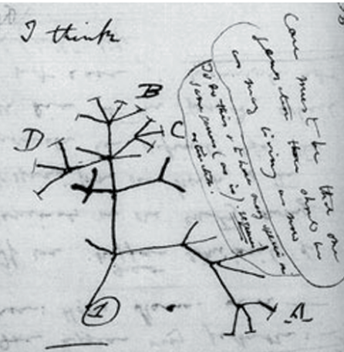

Labeled twigs are species alive today

Unnamed are extinct

* + - * + Branching process explains the variation that exist between related groups of organisms
      * **Artificial Selection**
        + Explain artificial selection, and describe how it led Darwin to his notion of natural selection.

Humans selecting desired traits through breeding inspired Darwin to connect a similar process that happened naturally

* + - * + Humans selective breeding of domesticated plants and animals to encourage the occurrence of desirable traits

As a result, crops, livestock animals, pets often are dissimilar to their wild ancestors

* + - * + 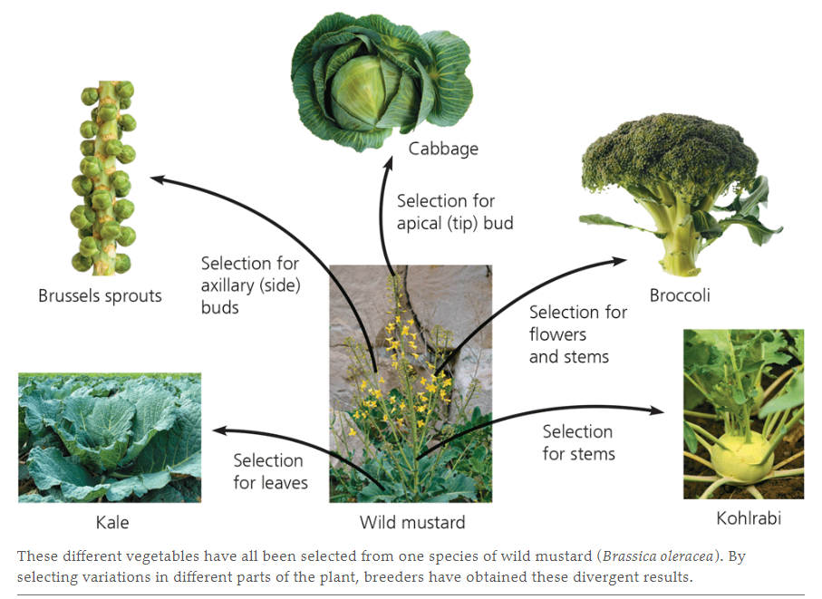
        + Argued that a similar process of human artificial selection happened in nature

Based on two core observations

Members of a population often vary in their inherited traits

Individuals with traits that help them survive and reproduce tend to leave more offspring than do other individuals

Use this picture to describe Darwin’s observation #1: Variations in traits exist. These variations (traits) are heritable. Identify some other examples? 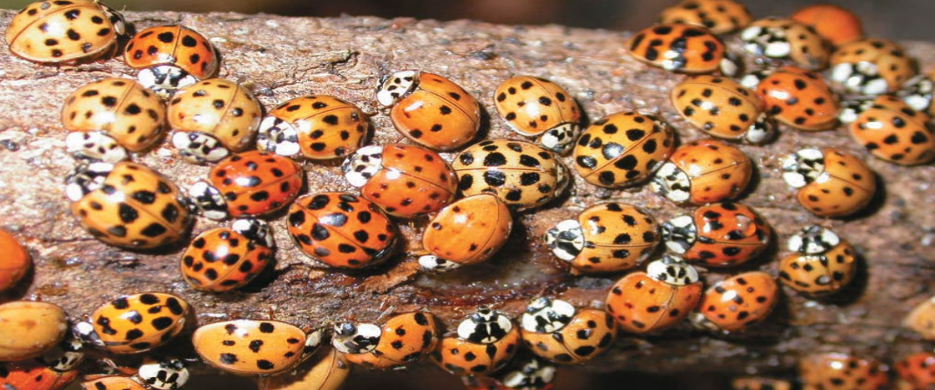

Traits that help an organism survive are more likely to produce offspring with such traits

Black bears & brown bears

All species can produce more offspring than their enviornmetn can support & many of these offspring die and fail to reproduce

Unequal ability of iniduvlas to survive and reproduce will lead to an abundance of favorable traits

Use this picture to describe Darwin's observation #2: Species overproduce. There is competition for resources and not all offspring survive. All species have this capability, even humans. Explain.

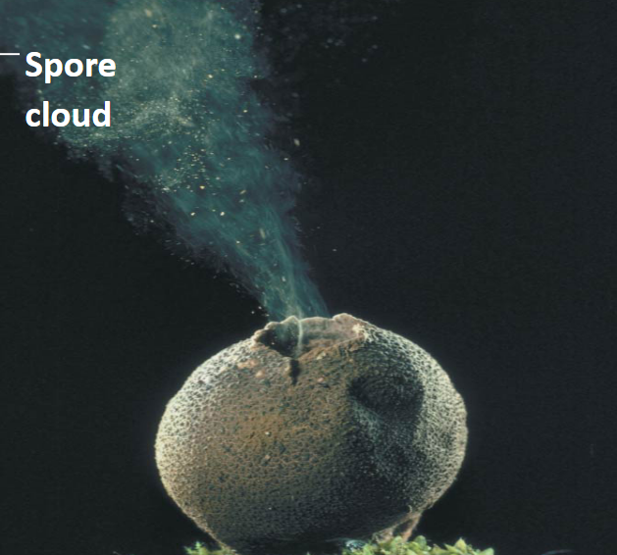

Because not all offspring can survive due to competition to attain resources, the offspring with traits better suited for an environment will survive & reproduce offspring such traits.

**Heritable Traits**

capable of being inherited or of passing by inheritance

Infeunce an organisms own performance & its offsprings

* + - * **Artificial** vs **Natural**
        + Artificial Brings ab dramatic change in a short period of time
        + Natural brings ab substantial modification of species over many hundreds of gnerations

### Ch 23.4 (7.3)

* + - ***Genetic Variation*** *makes evolution possible*
      * Differences among individuals in the composition of theri genes or other DNA sequences
        + Reflected in phenotypic variations